CUSTOMER SHOPPING BEHAVIOUR ANALYSIS

Developed by: Abdul Aziz Ujjan
Technology Stack: Python | SQL | Power BI
Project Type: End-to-End Business Intelligence Project
Date: January 2026

Business Problem:
The Objective of this project is to analyse the customer shopping behaviour, subscription patterns, revenue distribution, using business intelligence techniques. The analysis aims to identify key customer segments, high-performing product categories, and purchasing trends to support data-driven decision-making for marketing strategy, customer retention, and revenue growth.

Dataset Overview:
- Source: Kaggle
- No of Rows :3900
- Columns:18
- Key Columns:
- Customer (Age, Gender, Location, Subscription Status)
- Purchase Details (item purchased, Category, Purchase amount, size, colour, season)
- Shopping Behaviour (Discount Applied, promo code used, previous purchase, frequency of purchase, Review rating, shipping type)
- Missing data: 37 values in review rating column

Data Cleaning & Preparation:
- Missing values handling:
Missing values in the Review Rating column were filled by calculating the median review rating within each product category. This ensures that the imputed values remain consistent with the characteristics of the respective category.

- Duplicate removal
Duplicate records were removed during the data loading process in SQL to maintain data integrity and ensure accurate analysis. This ensured that only clean and unique records were stored in the database.

- Feature engineering
Feature engineering was performed by creating age groups, review rating labels, and purchase frequency labels to improve analytical insights. The Promo Code Used column was dropped because the same information was already represented through the Discount Applied field.

- Why Pandas was used
Pandas was used because it is a popular and efficient library for handling and cleaning data. It allows fast processing of Data Frames and CSV files and provides many useful functions that make data preparation easier and more reliable.

Data Modelling:
A normalized data model was designed to efficiently organize transactional and descriptive data while ensuring data integrity and scalability. The schema follows a fact–dimension structure, where descriptive attributes are separated into dimension tables and transactional measures are stored in a central fact table.
Dimension Tables
Dim Customer was created to store customer-related attributes, including demographic details such as age, gender, and age group, along with subscription status and purchasing behaviour indicators. This table enables customer segmentation and behavioural analysis.
Dim Item contains product-related information such as item name, category, size, and colour. Separating product attributes into a dedicated dimension allows flexible analysis of sales performance across different product characteristics.
Dim_Order_Details captures order-level information including location, season, shipping type, payment method, and discount application status. This dimension supports analysis of purchasing patterns based on ordering and fulfillment attributes.
Fact Table
Fact Sales serves as the central transactional table and records each purchase event. It includes foreign keys linking to the customer, item, and order dimensions, along with quantitative measures such as purchase amount, review rating, and previous purchase count. This structure enables accurate aggregation and performance analysis across multiple business dimensions.

SQL Analysis:
1.What is the total revenue generated by male vs. female customers?
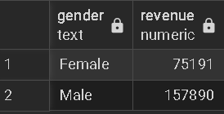
The query answers that Male customers contribute more to the revenue.

2. Which customers used a discount but still spent more than the average purchase amount?
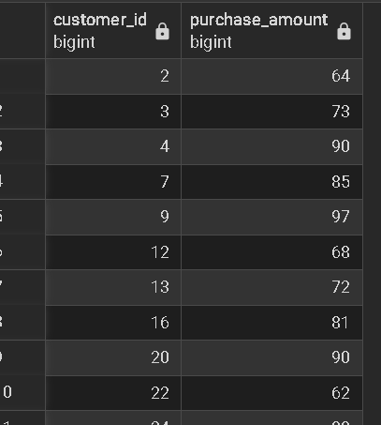
3. Which are the top 5 products with the highest average review rating?
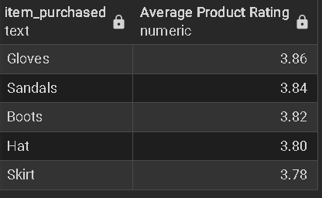
4. Do subscribed customers spend more? Compare average spend and total revenue
between subscribers and non-subscribers.
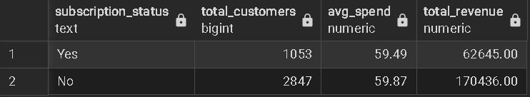
5. Segment customers into New, Returning, and Loyal based on their total
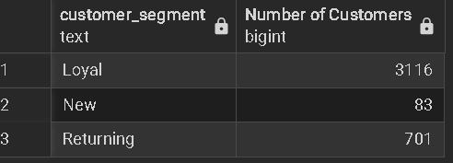
number of previous purchases, and show the count of each segment.

6. Are customers who are repeat buyers (more than 5 previous purchases) also likely to subscribe
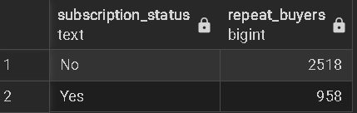
7. What is the revenue contribution of each age group?
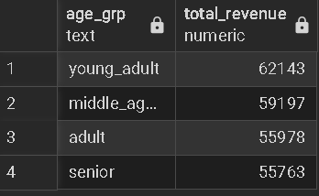

Power BI Dashboard:

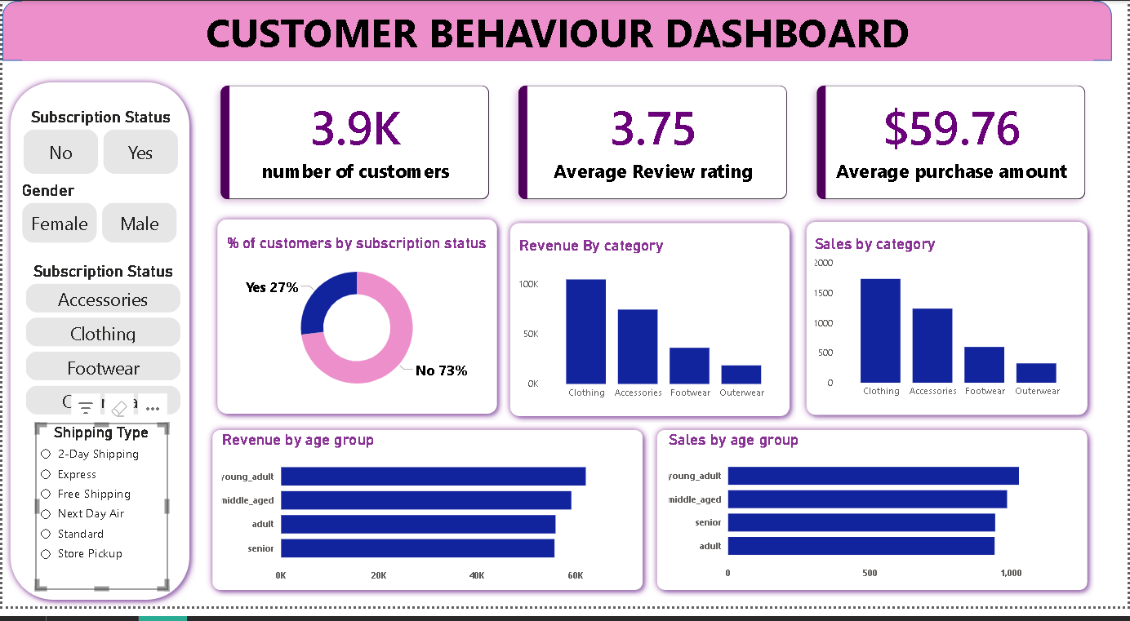

Business Recommendations:
- Increase Subscription Adoption
Since 73% of customers are non-subscribers, the business should focus on converting non-subscribers by offering limited-time discounts, loyalty rewards, or exclusive benefits for subscription members. Increasing subscription adoption can improve customer retention and recurring revenue.
- Prioritize High-Performing Categories Clothing and Accessories contribute the highest revenue and sales volume. Marketing campaigns, inventory planning, and promotions should prioritize these categories to maximize overall revenue impact.
- Target Young Adult and Middle-Aged Customers
Young adults and middle-aged customers generate the highest revenue and sales. Personalized marketing strategies, targeted advertisements, and tailored product recommendations should be designed specifically for these age groups.

- Improve Low-Performing Categories
Footwear and Outerwear show relatively lower sales and revenue. The business should evaluate pricing strategies, product variety, and promotional offers for these categories to improve their performance.
- Enhance Customer Experience Through Reviews
The average review rating of 3.75 indicates room for improvement. Improving product quality, delivery experience, and customer support can help increase customer satisfaction and lead to higher repeat purchases.
- Optimize Shipping Options
Analysis based on shipping types can help identify customer preferences. Promoting faster or cost-effective shipping options based on customer behavior may improve conversion rates and customer satisfaction.

Conclusion:
This project demonstrates an end-to-end business intelligence workflow, starting from data cleaning and preparation using Python, structured data modelling and analysis using SQL, and interactive visualization using Power BI. The dashboard provides valuable insights into customer behaviour, subscription patterns, and revenue distribution across categories and age groups. By leveraging these insights, businesses can make informed decisions to improve customer engagement, optimize product strategies, and drive sustainable revenue growth. This project highlights the importance of data-driven decision-making and showcases the effective use of BI tools for real-world business analysis.

